*The relation of Cannabis and industrial accidents*

By Alexey Kulik

### **Objectives**

The legalization of Cannabis was both politically popular but came with great regulatory hurdles on many fronts from keeping it away from children or creating fair detection rules for driving incidents. Having a once criminal drug become legal means that full stop bans are no longer as easily justifiable and thus enforcement of possibly reasonable bans require greater depth of analysis to justify.  
  
We looked at the relation between the overall population consumption of cannabis and the frequency of industrial workplace accidents. The health and safety of workers is something that the state and private business are both deeply interested in protecting for reasons of protecting human life which is also itself self-serving as it keeps the economy productive.

### **Data Preparation**

The data acquired comes directly from government verified statistics resources. This lends extensive credibility to the datasets to their validity and would be in the format relied upon by government regulatory agencies which would determine fair safe labour regulations. Being able to navigate, scan and work with government websites is essential for government work but also private consulting on issues in which only public data is available.

The problems of the data lies chiefly in the sample size. Time series data requires long term accurate measurement and perspective to work and the datasets obtainable publicly are not large enough to have strong confidence. The small size was then compensated for by doing a linear bulk up of the data, creating a larger data set which can be then used for interpolation of time series decomposition among other statistical tools. This thought is also the greatest flaw of the overall analysis; it makes the final correlation and findings weak. At best the data is suggestive of further analysis. The data is also normalized so that predictive models can better work with the data sets.

### **Analysis or model**

Analysis begins at the base level with descriptive statistics of the data over time.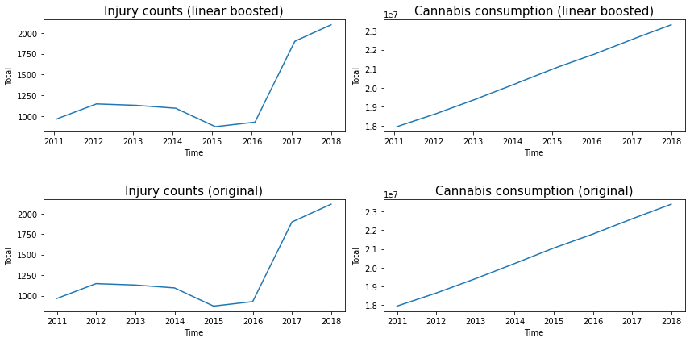

As you can see there is a linear trend of cannabis consumption over time with injuries having a non-linear trend until the late 2010s where there is a massive spike.

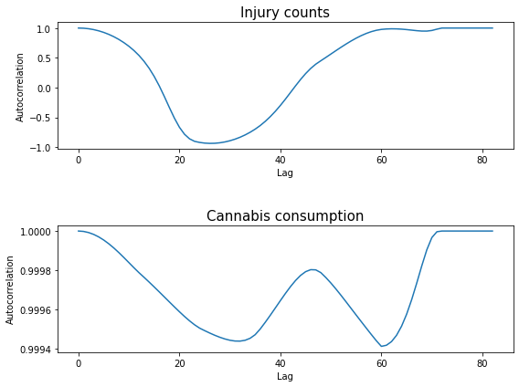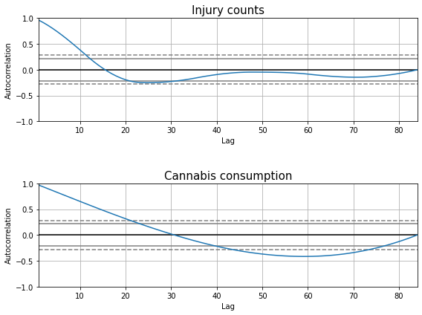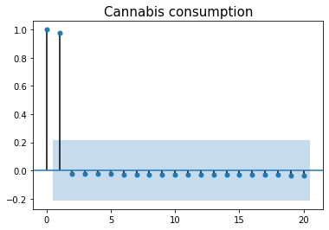



Doing auto-correlation analysis clearly shows the graphed spikes extremely close to zero with lag times beyond 2. This very heavily suggests that the data is not auto-correlated which means that usage of models that assume linear trends can be used well maintaining accuracy.

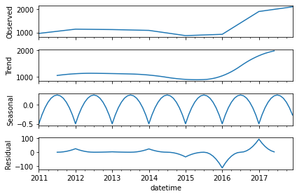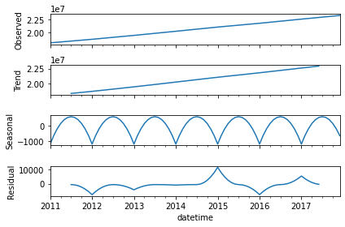

The next analysis is done through the comparison and contrast of multiplicative and additive models for the time series, seeing which is more suggestive and powerful in predicting the general trend of our data.

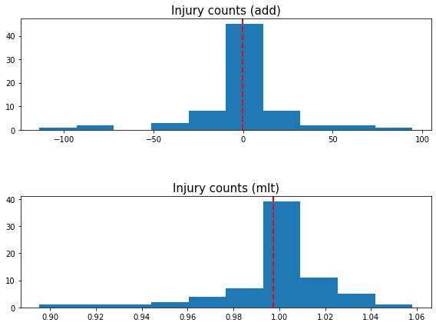

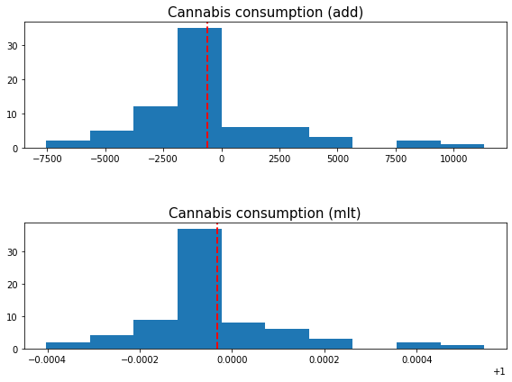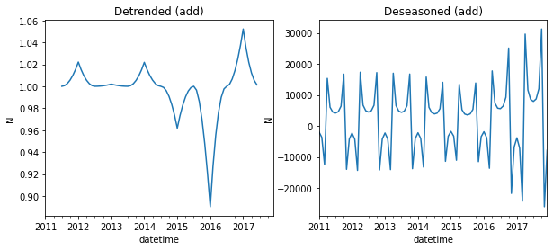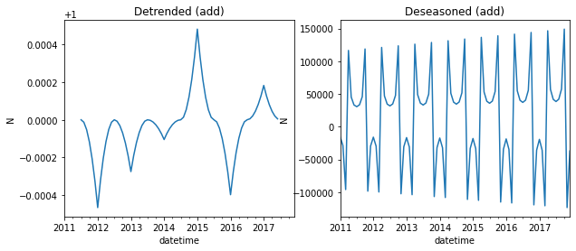

These showcase the overall numbers that for

injuries :

*Strength of trend is: 1.000*

*Strength of seasonality is: 0.011*

And for Cannabis Consumption:

*Strength of trend is: 1.000*

*Strength of seasonality is: 0.037*

Finally modeling was done for predictive forecasting. Breaking up the data set into training and validation sections at roughly 70% and 30% respectively. And this ARIMA model was trained which works perfectly with our single variable data.

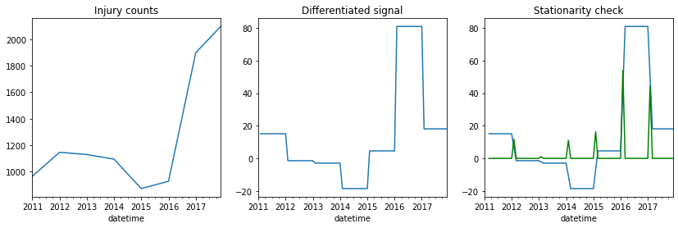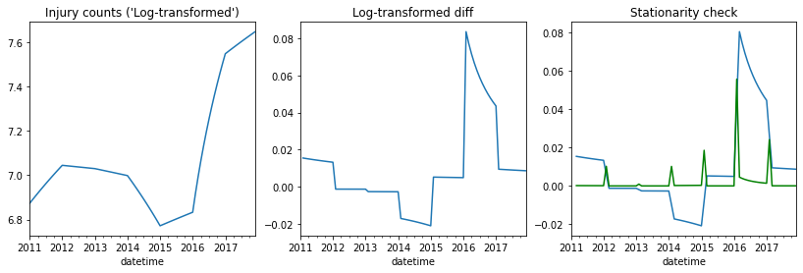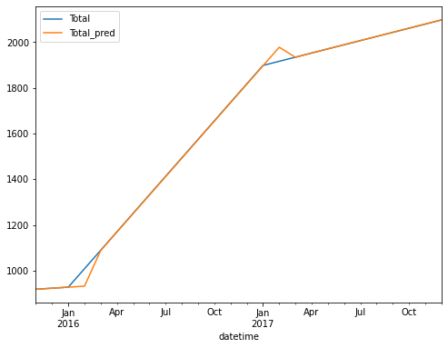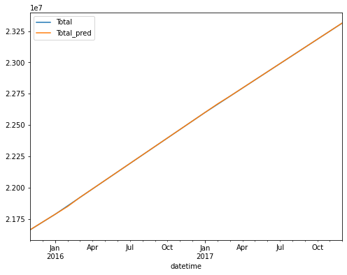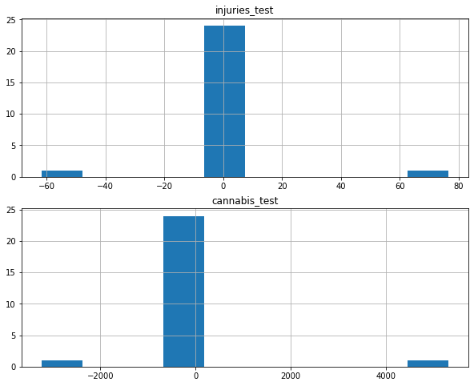

The model found with high accuracy and with low relative error the predicted values. This gives good cause to our hypothesis that increased cannabis use leads to relatively higher industrial workplace accidents.

### **Conclusion**

Although we found through statistical analysis that there is suggestive evidence for cannabis causing higher workplace accidents it is hard to draw true conclusions from this. This primarily from our low time scale data set but also the fact that we didn’t look comparatively at other contexts other countries such as the Netherlands or Mexico have legalized Cannabis consumption and perhaps they didn’t see a similar rise in workplace accidents. Perhaps the spike in workplace accidents come from an increase in other substances such as Alcohol or harder drugs such as the opioid epidemic. We also didn’t look at the survey data itself in that perhaps the way in which accidents are defined or collected changed or the cannabis survey had great inaccuracy due to it being an illegal substance. All of this foundational and comparative points would be essential to any great conclusion being given on the relationship explored.

### **Bibliography**

“Occupational Health and Safety Worker Fatality and Critical Injury Counts Report.” Edited by Labour, Training and Skills Development, *Occupational Health and Safety Worker Fatality and Critical Injury Counts Report* , Government of Ontario, 11 Jan. 2020, <https://open.canada.ca/data/en/dataset/f3e63186-8401-4c9e-a490-1f9e7d7eb00b>.

Statistics Canada. “Prevalence of Cannabis Consumption in Canada.” *Open Government Portal*, Statistics Canada, 20 Oct. 2018, <https://open.canada.ca/data/en/dataset/d6b45dd5-22eb-4b24-b37f-ed22469f093f>. Modified on 2021-10-28